SUSTAINABILITY CROSSWORD
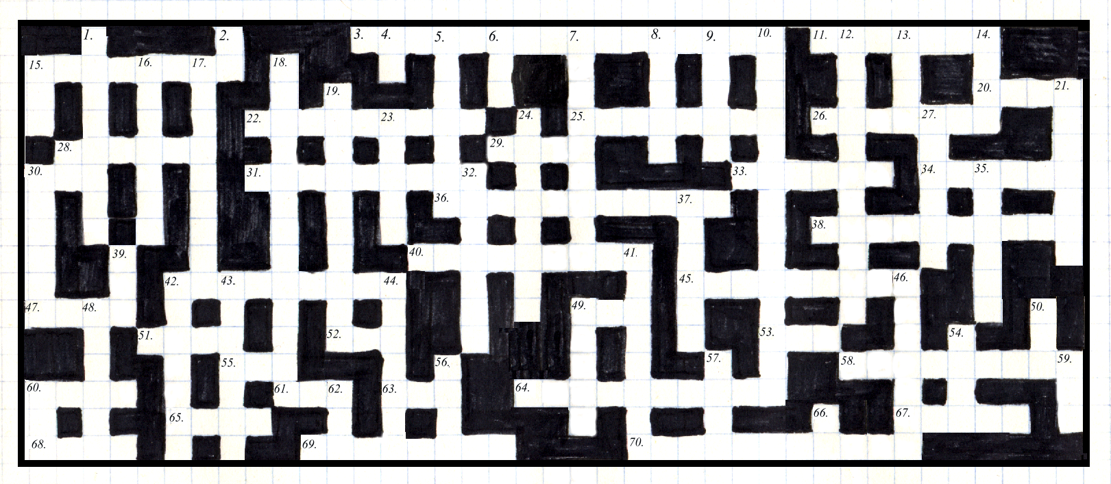

ACROSS CLUES:
DOWN CLUES:

3. Rights and _____ (16)
11. Sustain (7)
15. Development (8)
20. Cartography (4)
22. People Power (9)
25. ‘____ Properties’ of systems (8)
26. ‘Reduce, Re-Use, _____’ (7)
28. The best place ever (6)
29. Subsequently (4)
30. Prefix which denotes ‘one’ (3)
31. Utilitarianism: The ___ Principle (9)
33. Human Freedoms (6)
34. Study of Right and Wrong (6)
36. Able to replenish indefinitely (11)
38. Untouched nature (10)
40. Nature has _____ Value (9)
42. Trade, efficiency and equity (9)

45. An informative measure (9)
47. Demonstration (4)
49. Primary source of energy (3)
51. Time scale for sustainability (4)
52. A pleasing response (3)
53. Denotes an Ideology (3)
55. Gaseous (3)
58. Economic ____ of environment (9)
60. Fair trade, not ____ trade (4)
61. Balance: ____ and Yang (3)
63. Environmental Impact Assessment (3)
64. Science plus Engineering (10)
65. Mother Earth (4)
67. Lungs of the Earth (5)
68. Subsystems ____ within systems (4)
69. Must ____ resources and energy (8)
70. Enough, without excess (11)

1. ____ feedback (8)
2. Ultimately, it is up to ___ (2)
4. Example (2)
5. Action causing change (7)
6. World Wide Web (3)
7. _____ is ‘Love of Life’ (9)
8. Within (4)
9. Between (4)
10. Ultimate management objective (14)
12. Ignorance and Risk (11)
13. Prefix which denotes ‘many’ (4)
14. Temporal (4)
15. Denotes ‘before’ (3)
16. Confucianism: ___ your elders (7)
17. Coordinated towards a goal (9)
18. Avoiding irreversible damage (13)
19. Many non-simple interactions (10)
21. Survive on a bare minimum (7)
23. Sun, wind etc: ____able energy (5)
24. Law functions to ___ people (8)
27. Intelligent (6)
28. United Nations (2)
30. ____ we stand, divided we fall (6)
32. Maintain at the same level (7)
35. Famine (6)
37. A finite world has _____ (6)
39. Genetically Modified Organism (3)
41. Context outside, and ____ inside (8)
42. Organisms and their habitat (7)
43. Food grown without pesticides (7)
44. Structure and arrangement of things (7)
46. Cyber-environment: Virtual ____ (7)
48. Approximations of the real-world (6)
49. Three-dimensional (5)
50. Conservation of ___diversity (3)
54. Change per unit of time (4)
56. Sadly, life’s not always ___ (4)
57. Basics: Food, clothes and a ___ (4)
59. When? (3)
60. Try to choose work that is ___ (3)
62. Non-Government Organisation (3)
66. Together, ___ can do it! (2)

